CALENI PRACTICE HELP DOCUMENT FOR ADMINISTRATORS



**About the help document**

*This document explains how an administrator can use the Caleni Practice system which caters to creating appointments, schedules, patients, psychologists, center, complaints and announcements*

**Table of Contents**

Contents

1.Dashboard 4

2.Center 5

2.1 Adding a center 5

2.2 View, Edit, Delete, Search Center 5

3.Psychologist 7

3.1 Add a Psychologist 7

3.2 View, Edit, Delete, Search Psychologist 7

4.Patients 9

4.1 View, Edit, Delete, Search a Patient 9

5.Announcement 10

5.1 Add an announcement 10

5.2 View, Edit, Delete, Search Announcement 10

6.Complaints 12

6.1 View, Respond, Delete, Search a Patient 12

7.Payment 13

7.1 Add and Print a Payment Invoice 13

7.2 View, Search a List of Payments 14

8.Schedule 15

8.1 Add a schedule 15

9.Manage User Details 16

9.1 Change Password 16

# 1.Dashboard

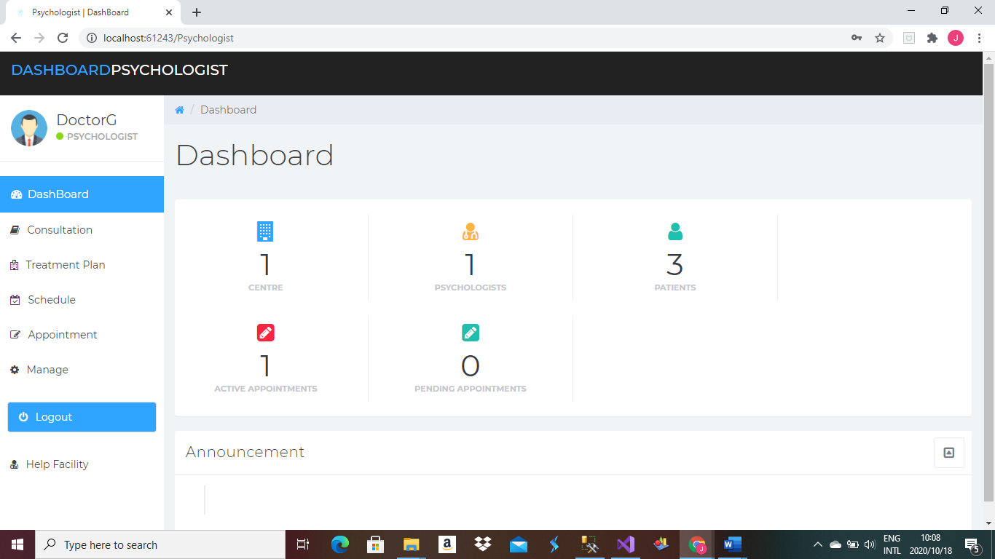

Immediately when you enter login to the system

The first thing that will appear is the dashboard

The numbers of centers, psychologist, patients, announcements will be displayed.

# 2.Center

## 2.1 Adding a center

Figure 2.1

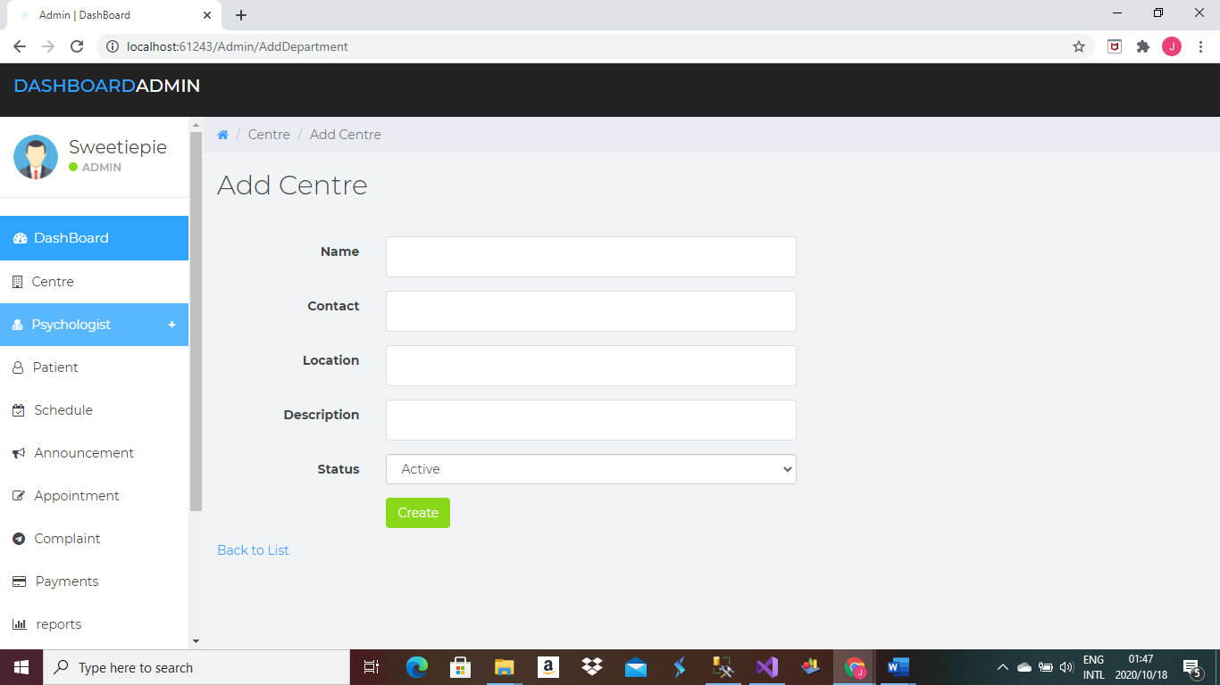

Click on the side navigation menu -> Add Center

The page (Figure 2.1) will appear-> Enter all required details click create

## 2.2 View, Edit, Delete, Search Center

Figure 2.2

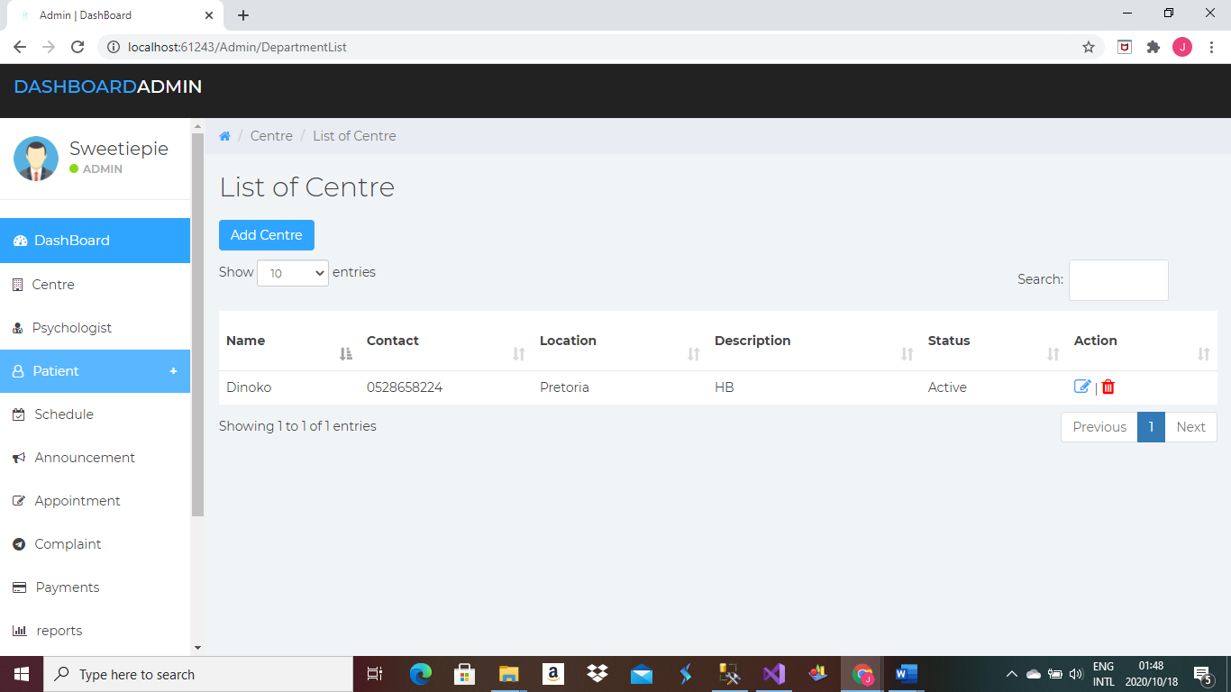

Click on the side navigation menu -> List of Center

The page (Figure 2.2) will appear->

To edit center-> Click on the edit button(blue pen) under Action heading

To delete center-> Click on the delete button(red bin) under Action heading

# 3.Psychologist

## 3.1 Add a Psychologist

Figure 3.1

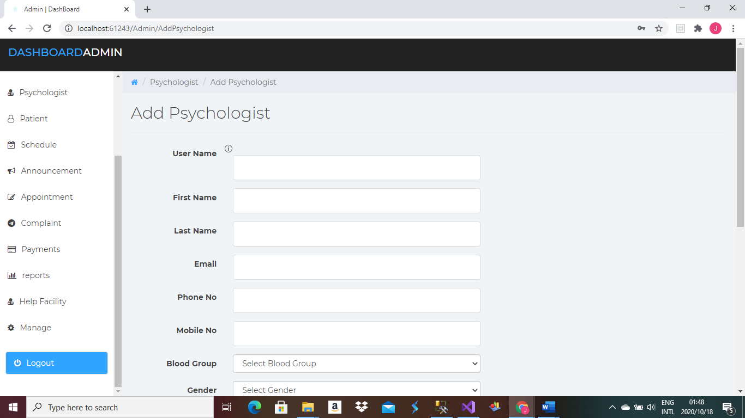

Click on the side navigation menu -> Add Psychologist

The page (Figure 3.1) will appear-> Enter all required details click create

## 3.2 View, Edit, Delete, Search Psychologist

Figure 3.2

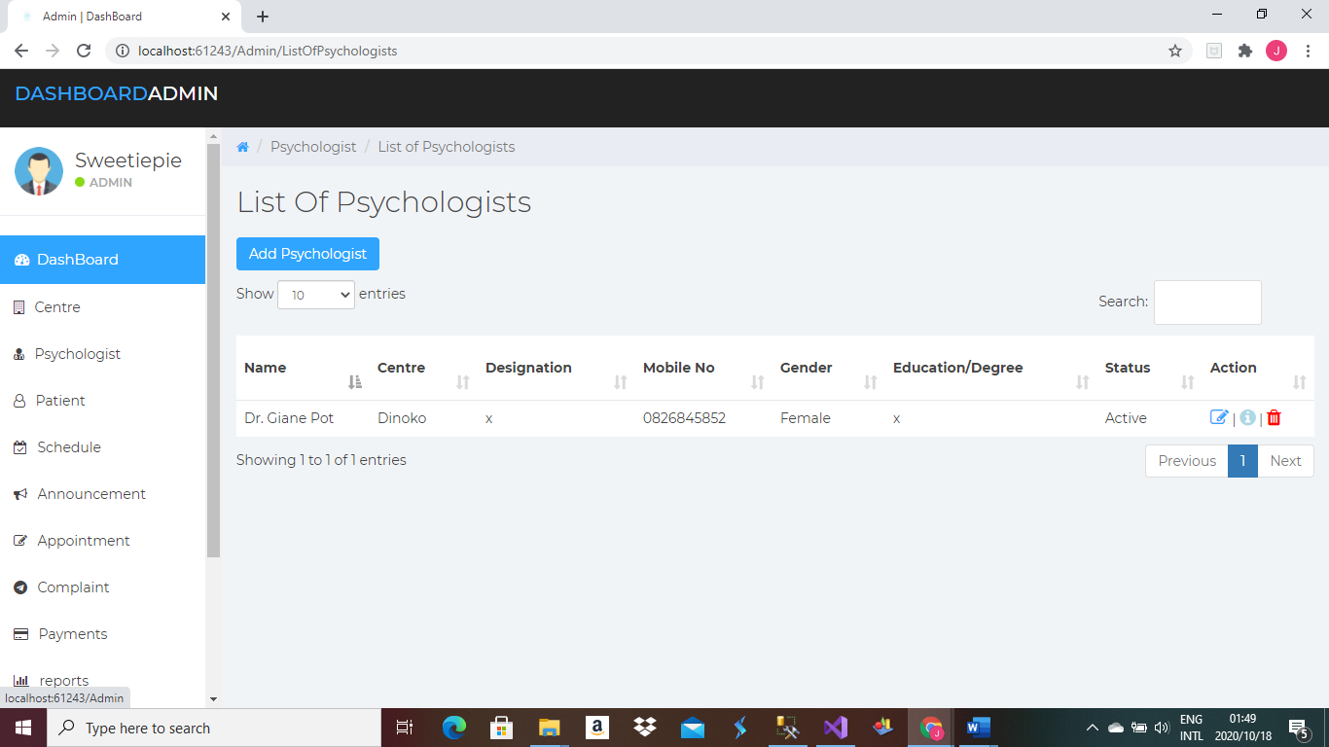

Click on the side navigation menu -> List of Psychologists

The page (Figure 3.2) will appear->

To edit psychologist-> Click on the edit button(blue pen) under Action heading

To delete psychologist-> Click on the delete button(red bin) under Action heading

# 4.Patients

## 4.1 View, Edit, Delete, Search a Patient

Figure 4.1

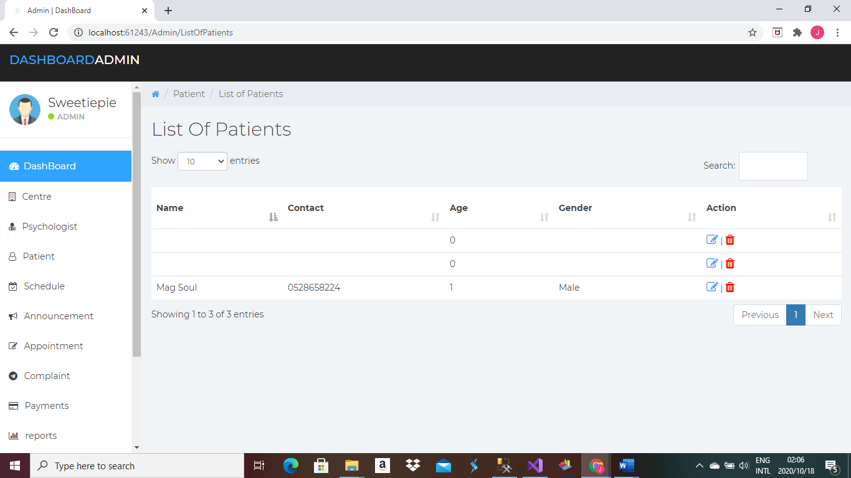

Click on the side navigation menu -> List of Patients

The page (Figure 4.1) will appear-> You can view all registered patients

To edit patient-> Click on the edit button(blue pen) under Action heading

To delete patient> Click on the delete button(red bin) under Action heading

# 5.Announcement

## 5.1 Add an announcement

Figure 5.1

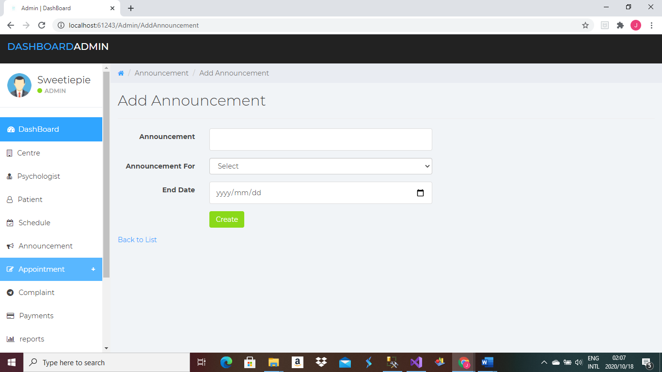

Click on the side navigation menu -> Add Announcement

The page (Figure 5.1) will appear-> Enter all required details click create

## 5.2 View, Edit, Delete, Search Announcement

Figure 5.2

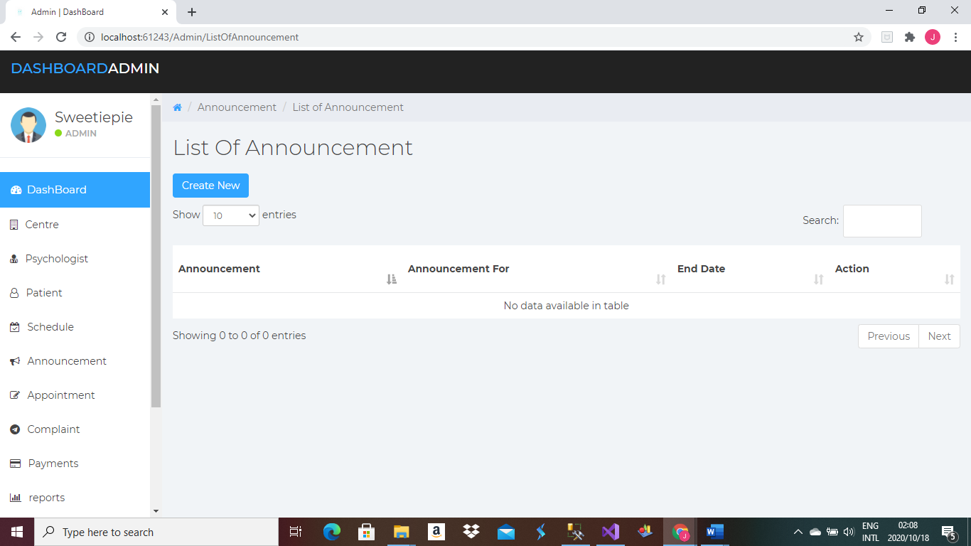

Click on the side navigation menu -> List of Announcements

The page (Figure 5.2) will appear-> You can view all announcements

To edit announcement> Click on the edit button(blue pen) under Action heading

To delete announcement> Click on the delete button(red bin) under Action heading

# 6.Complaints

## 6.1 View, Respond, Delete, Search a Patient

Figure 6.1

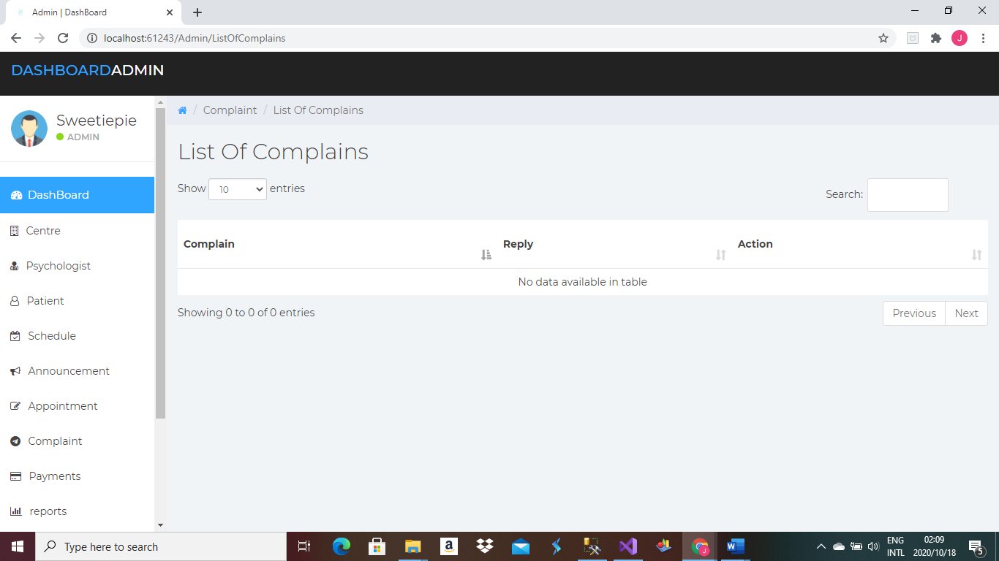

Click on the side navigation menu -> List of Complaints

The page (Figure 6.1) will appear-> You can view all complaints

To respond to a complaint-> Click on the edit button(blue pen) under Action heading

To delete complaint> Click on the delete button(red bin) under Action heading

# 7.Payment

## 7.1 Add and Print a Payment Invoice

Figure 7.1

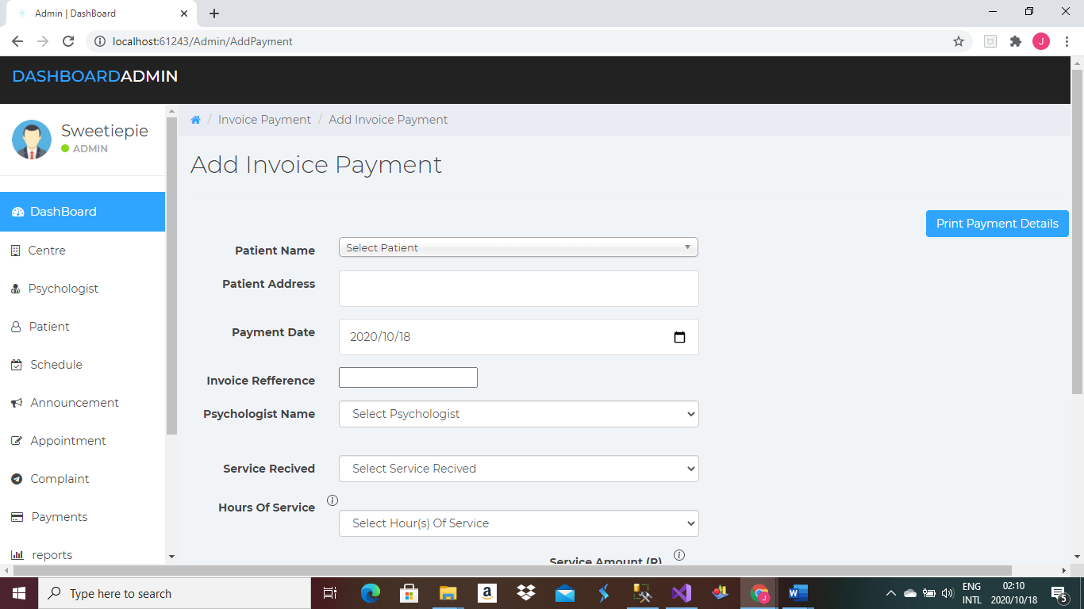

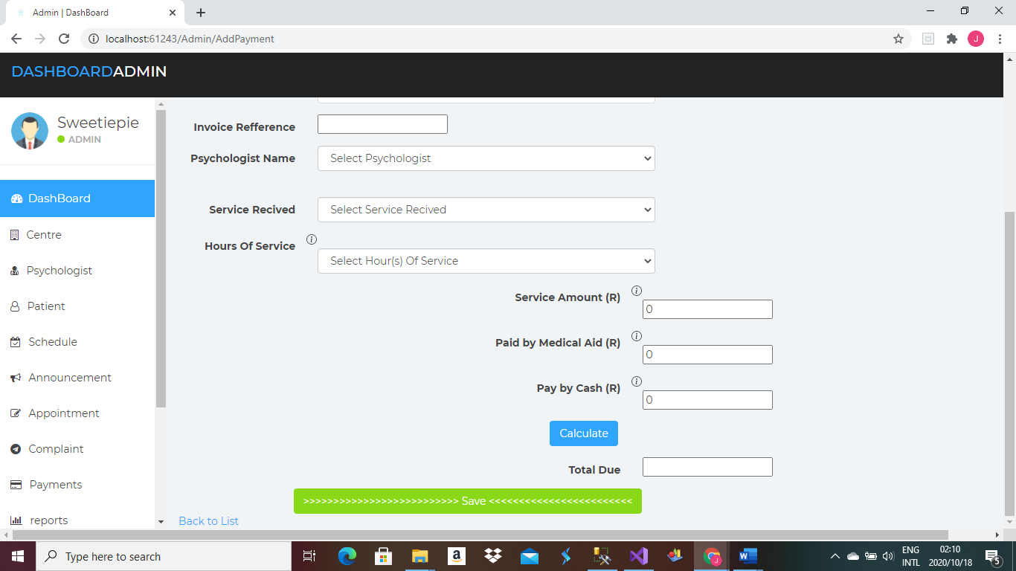

Click on the side navigation menu -> Payment

The page (Figure 7.1) will appear-> Enter all required details click save

To print invoice-> Click Print payment invoice

## 7.2 View, Search a List of Payments

Figure 7.2

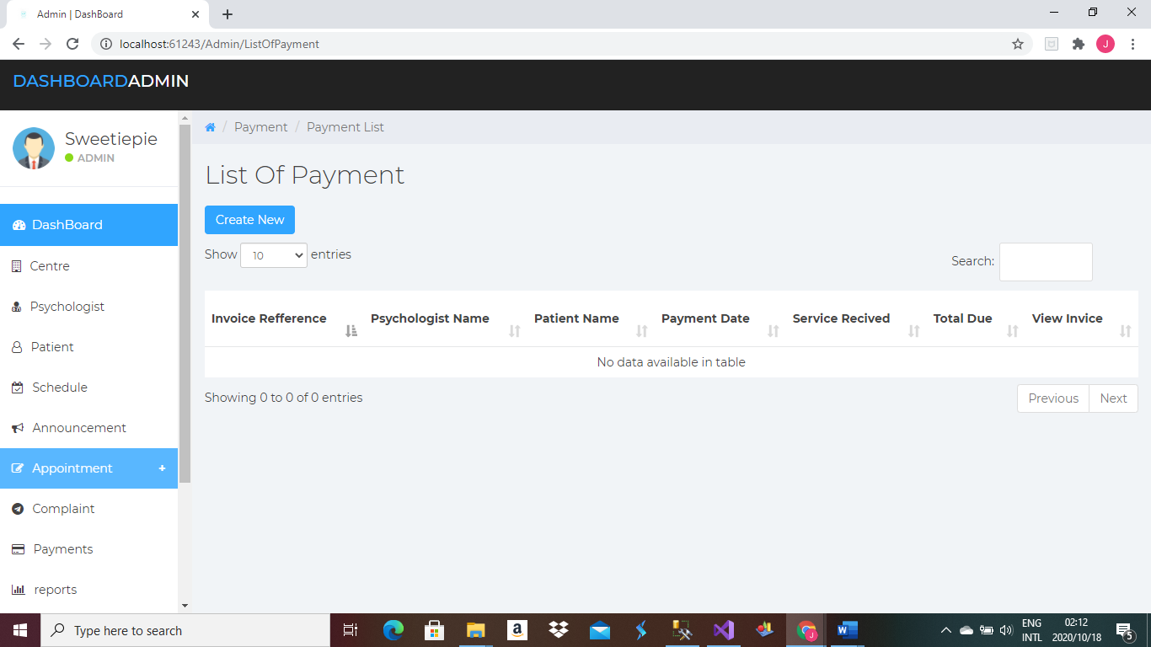

Click on the side navigation menu -> List of Payments

The page (Figure 7.2) will appear-> You can view all payments

To view a single invoice-> Click on view button under Action heading

# 8.Schedule

## 8.1 Add a schedule

Figure 8.1

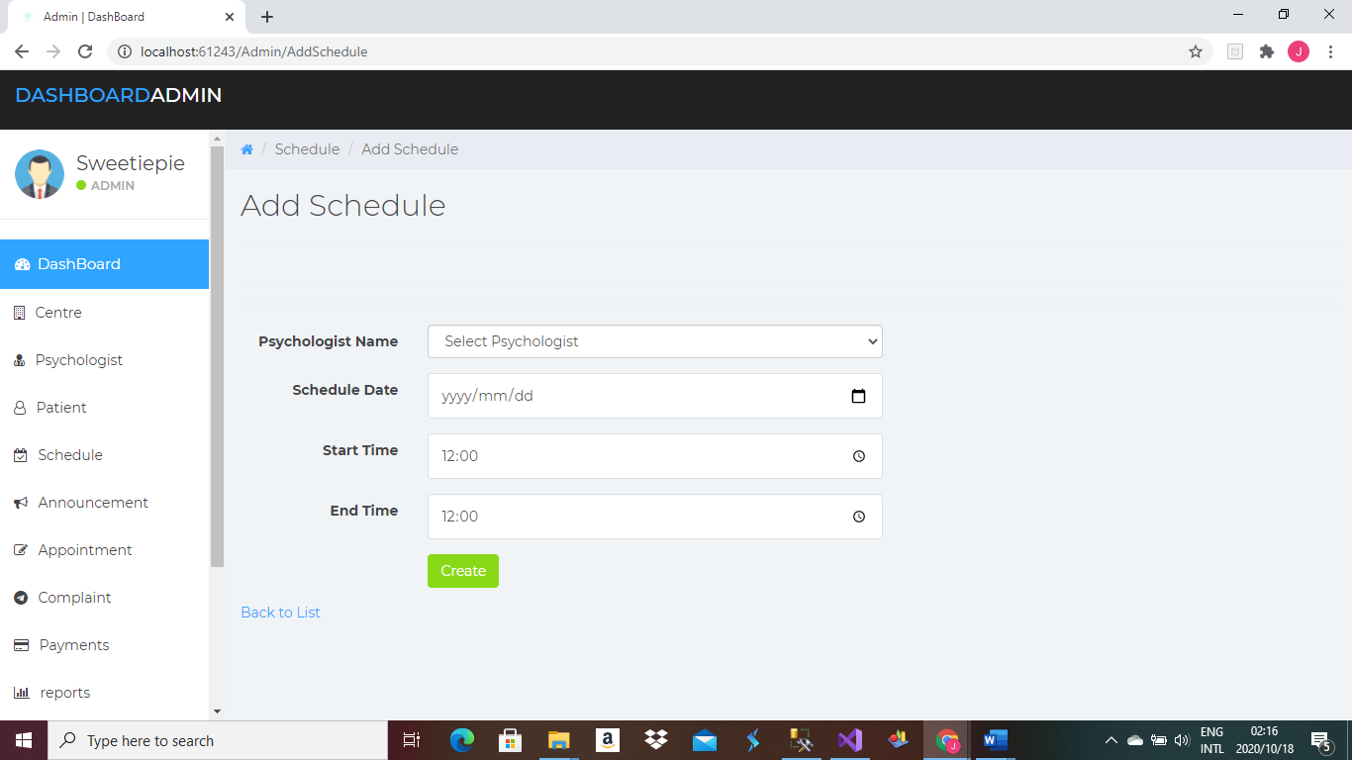

Click on the side navigation menu -> Add Schedule

The page (Figure 8.1) will appear-> Enter all required details click create

# 9.Manage User Details

## 9.1 Change Password

Figure 9.1

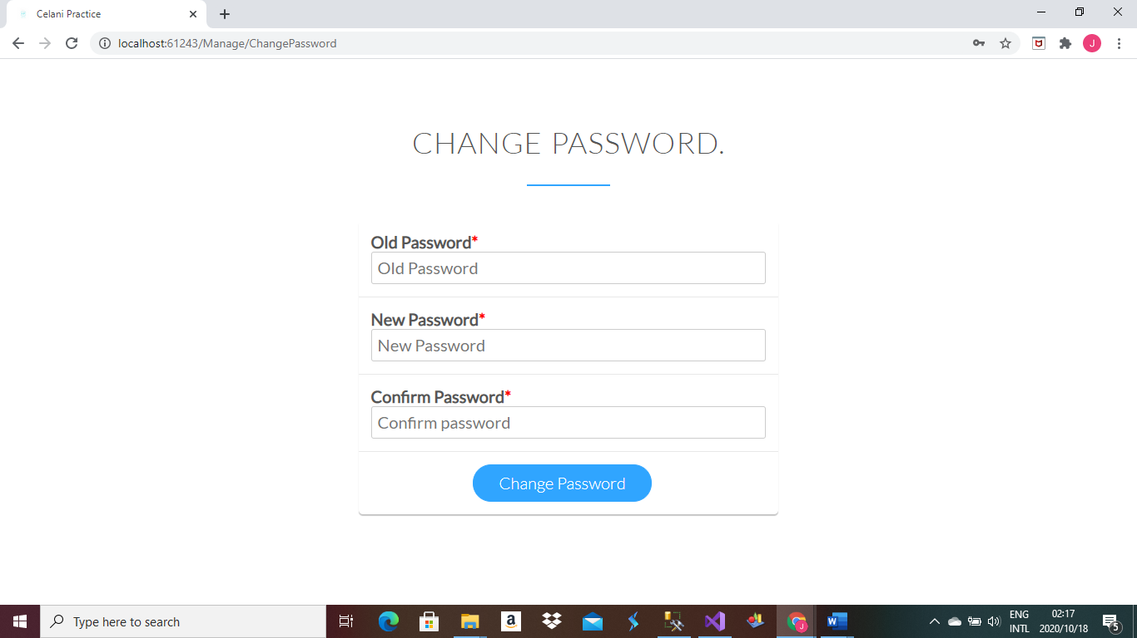

Click on the side navigation menu -> Manage

The page (Figure 9.1) will appear-> Enter old password, new password and confirm new password. Click Change Password